PHP and MySQL

Week 3 Practical Forms

Exercise 1
Create a new HTML file called wk3ex1.html and insert the code below.
<html>
<head>
<title>HTML form submitted to php file</title>
</head>
<body>

<form action="wk3ex1action.php" method="post">
Enter your name
<input type="text" name="txtname" size="30"/><br/><br/>
Gender
<input type="radio" name="radsex" value=”male” />Male
<input type="radio" name="radsex" value="female" />Female
<input type="radio" name="radsex" value="other" />Other <br/><br/>
Occupation
<select name="seloccupation">
<option>Lecturer</option>
<option>Beach Bum</option>
<option>Traffic Warden</option>
</select></br></br>
<input type="submit" value="display">
</form>
</body>
</html>

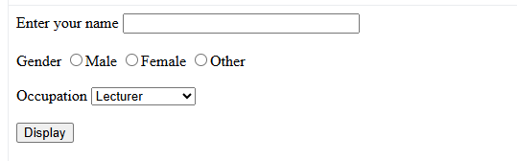
Now create a PHP file called wk3ex1action.php and include the code below.
<html>
<head>
<title>Response to form</title>
</head>
<body>
<?
echo "Your name is $_POST[txtname]”;
echo "Your gender is $_POST[radsex]”;
echo "Your occupation is $_POST[seloccupation]”;

?>
</body>
</html>

Load wk3ex1.html into your browser, enter the details and click on the submit button.
The contents of the form defined within wk3ex1.html, are sent to the file specified by the form’s action attribute. You can access the contents of any control within the form defined in wk3ex1.html from within the wk3ex1action.php script via the $_POST array. The latter uses the name of each control to index the associative elements.
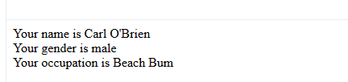

Exercise 2
Create a new HTML file called wk3ex2.html and insert the code below.

<html>
<head>
<title>Selection Exercise 1</title>
</head>
<body>
<form action="wk3ex2action.php" method="post">
Enter your age :
<input type="text" name="txtage"/><br/>
<input type="submit"/>
</form>
</body>
</html>

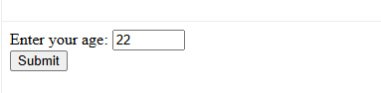

Now create a PHP file called wk3ex2action.php and include the code below.
<?
if ($_POST[“txtage”] < 21)
{
echo "You are under 21 years old<br/>";
}
else
{
echo "You are 21 years old or over<br/>";
}
?>

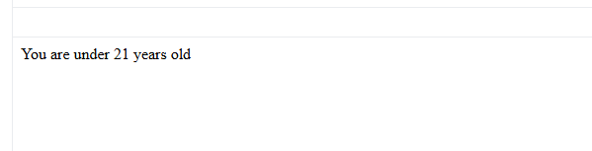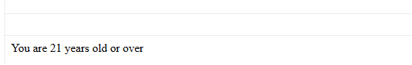

Run wk3ex2.html, enter your age and click on submit.
Amend wk3ex2.html to include a second text box called txtgender. Now add an ‘if’ statement to wk3ex3action.php, to output a different message for an input of “Male” or “Female”.
Hint the comparison operator in Php is ==
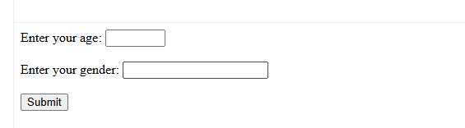
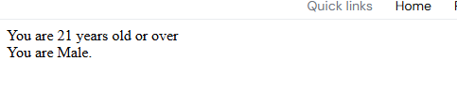

Exercise 3
Create the file below and save it as wk3ex3.html.

<html>
<head>
<title>Selection Exercise 2</title>
</head>
<body>
<form action="wk3ex3action.php" method="post">
Select your course
HNC<input type="radio" name="radcourse" value="HNC"/><br/>
HND<input type="radio" name="radcourse" value="HND"/><br/>
BSC<input type="radio" name="radcourse" value="BSC"/><br/>

<input type="submit">
</form>
</body>
</html>

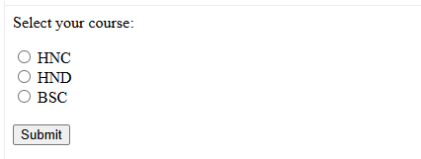

Save the file below as wk3ex3action.php and run wk3ex3.html
<?
switch ($_POST[“radcourse”])
{
case "HNC" : echo "You have selected an HNC course";
break;
case "HND" : echo "You have selected an HND course";
break;
case "BSC" : echo "You have selected a BSC course";
break;
default : echo "No course selected";
}
?>

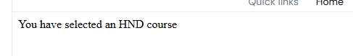
The switch statement is useful when you have many comparisons to make, an example being selecting a menu option.
Add a new course “Part Time BSC” to wk3ex3.html and ensure wk3ex3action.php responds to this option if it is selected. Now remove all the breaks from wk3ex3action.php.
How is the output effected ?

What does the break statement do ?

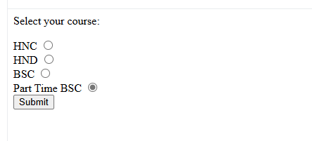
“How is the output affected” Output:
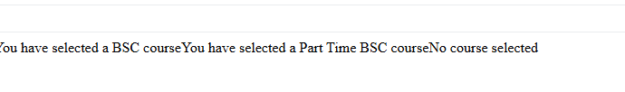
The break statement essentially stops the switch statement from continuing to evaluate the other cases statements once a match has been found. Without it also, it will print multiple messages instead of just the one which matches the users input.

Exercise 4
We can add persistence to our scripts by writing to and reading from files. The Guestbook exercise demonstrates how a single script can display an html form, which allows the user to enter a message. The message is then appended to a text file using the fputs function. Finally the ReadFile function outputs the whole contents of the file onto the web page.
Reproduce the Guestbook script naming it guestbook.php and try it out.
<html>
<head>
<title>My Guestbook</title>
</head>
<body>

<h1>Welcome to my Guestbook</h1>
<h2>Please write me a little note below</h2>

<form action="<?php echo htmlspecialchars($_SERVER['PHP_SELF']);?>" method="POST">

<textarea cols=40 rows=5 name=note wrap=virtual></textarea>
<input type=submit value=" Send it ">
</form>

<?php
if(isset($_POST[note]))
{
// Substitute your login in place of "yourLogin"
$fp = fopen("yourLogin.txt","a");
fputs($fp,nl2br($_POST[note]).'<br>');
fclose($fp);
}
?>
<h2>The entries so far:</h2>

<?php
// Substitute your login in place of "yourLogin"
@ReadFile("yourLogin.txt")
?>
</body>
</html>

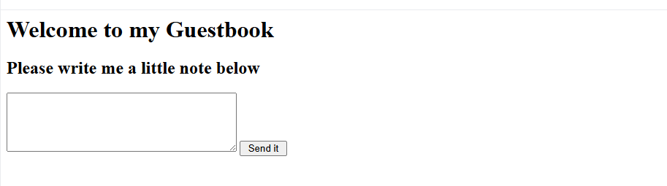

The fopen(…) ‘a’ mode parameter allows php to write to a text file and will also means that php will attempt to create “yourLogin.txt” if it doesn’t already exist (see http://uk.php.net/manual/en/function.fopen.php).

If the server settings don’t allow scripts to create a file, you may need to create the yourLogin.txt file on the server manually. Place it in the same directory as the script.

Set the user, group and other file permissions (right click – properties in Winscp/CoreFTP) to ‘read’ and ‘write’ (see screen capture below).

WinSCP: FileZilla:
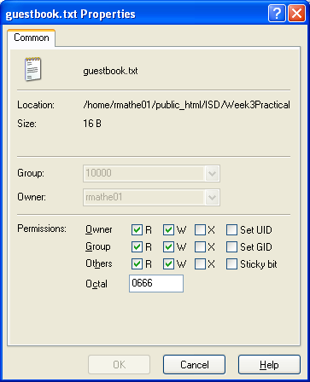
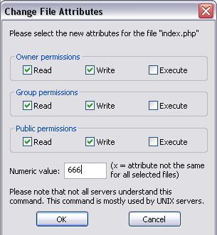

Exercise 5

Complete the third unit on the SoloLearn PHP course either via the web or via the mobile: https://www.sololearn.com/Play/PHP

In your final logbook/handout, you will be asked to provide evidence that you completed the whole course in the form of a screenshot of your progress or a screenshot of the certificate of completion.

